**BUG 1**

**Summery: The add operation is not working correctly**

**Environment/URL:** Calculator-app.exe

**Operation System:** Windows 64

**Version**: 1

**Browser:** Google Chrome

**Submit Date:** 3/30/2023

**Reporter:** Anahit Zakaryan

**Steps to Reproduce:**

1. Open calculator-app.exe
2. Click the Exercises, then Calculator button
3. Enter 1 in input field number 1
4. Enter 1 in input field number 2
5. The addition operation is the first in the list, so we leave it unchanged
6. Click on the Calculate button

**Expected Result:** The result of the addition should be 2

**Actual Result:** The answer is 0

**Screenshot/video:** Screenshot is attached

**Notes:** Tested other number combinations (integer, decimal, combination of - and + signs) and always the answer is less than -2․

**References: -**

**Severity:** Critical

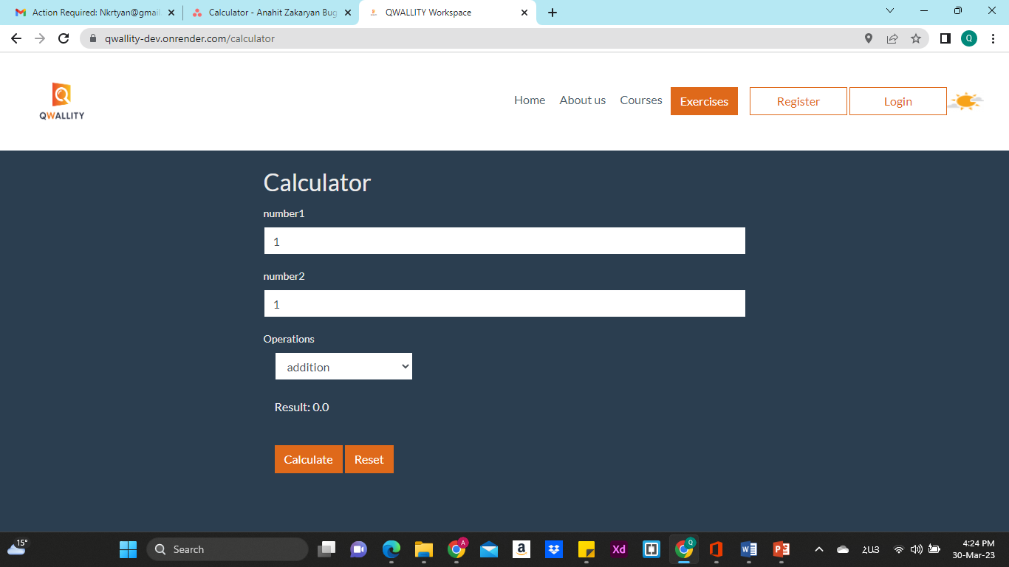

**BUG 2**

**Summery: Validation message-text error in division section**

**Environment/URL:** Calculator-app.exe

**Operation System:** Windows 64

**Version**: 1

**Browser:** Google Chrome

**Submit Date:** 3/30/2023

**Reporter:** Anahit Zakaryan

**Steps to Reproduce:**

1. Open calculator-app.exe
2. Click the Exercises, then Calculator button
3. Enter 1 in input field number 1
4. Enter 0 in input field number 2
5. Select the division operation from the list
6. Click on the Calculate button

**Expected Result:** Display a validation error message that "The number is not divisible by 0" or "Can not divide by zero"

**Actual Result: "**Can not devide by zro"

**Screenshot/video:** Screenshot is attached

**Notes:** No errors were found when dividing by other combinations of numbers (whole numbers, decimal fractions, a combination of signs - and +).

**References: -**

**Severity:** Мedium

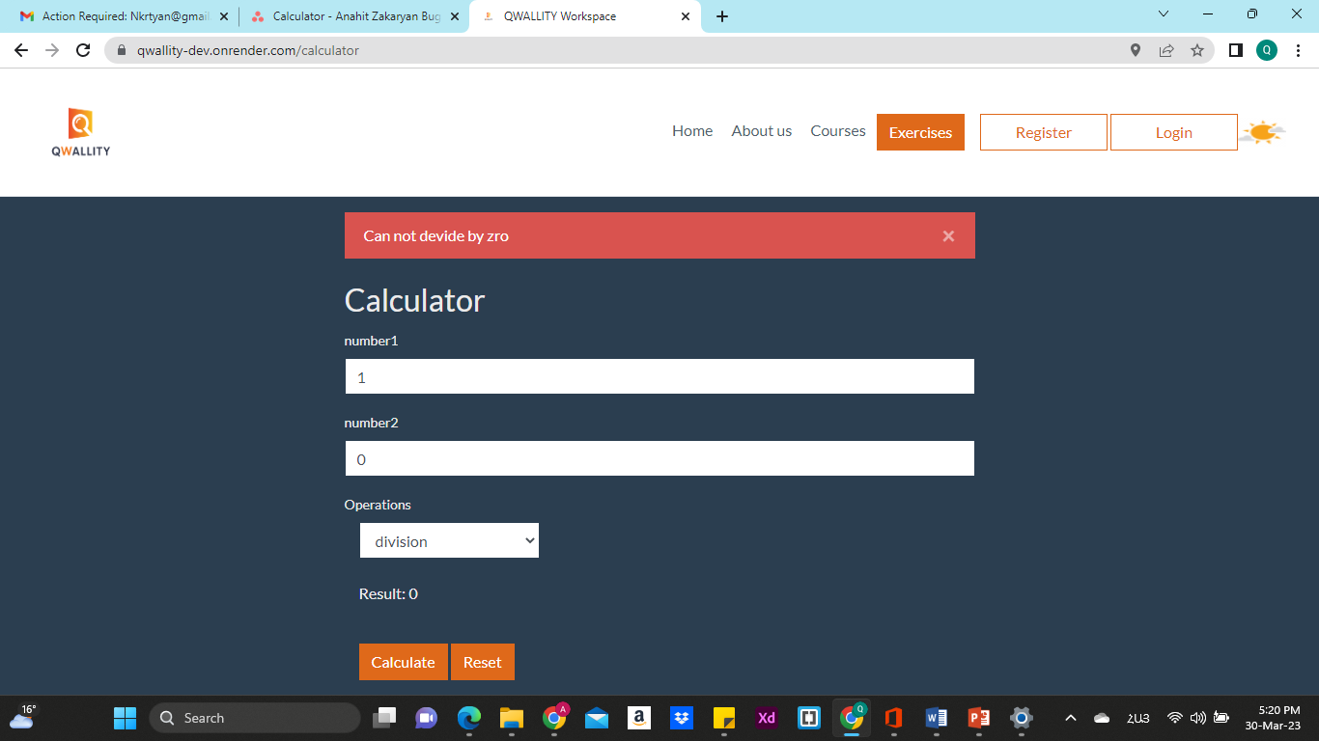

**BUG 3**

**Summery: Reset is not working correctly**

**Environment/URL:** Calculator-app.exe

**Operation System:** Windows 64

**Version**: 1

**Browser:** Google Chrome

**Submit Date:** 3/30/2023

**Reporter:** Anahit Zakaryan

**Steps to Reproduce:**

1. Open calculator-app.exe
2. Click the Exercises, then Calculator button
3. Enter 4 in input field number 1
4. Enter 2 in input field number 2
5. Select the any operation from the list
6. Click on the Calculate button
7. Click on the Reset button

**Expected Result:** Clear input data from input fields (number 1, number 2) and calculated result.

**Actual Result:** Cleared only calculated result

**Screenshot/video:** Screenshot is attached

**Notes:** I didn't mention the (-, +, *, /) operations because I think it works as it should after the reset.

**References: -**

**Severity:** Low

